**FUNCTION POINTERS**

**1. WAP to invoke functions below based on user input character using function pointer. Character mapping and respective functions to be invoked are given below.**

|  |  |
| --- | --- |
| **Character input** | **Function** |
| **+** | **int add(int x, int y)** |
| **-** | **int sub(int x, int y)** |
| **\*** | **int multiply(int x, int y)** |
| **/** | **int divide(int x, int y)** |

**OUTPUT:**

**2. Extend Q1 to include a function below which will return the address of a function based on input character.**

**<address of function> getaddr(char mychar);**

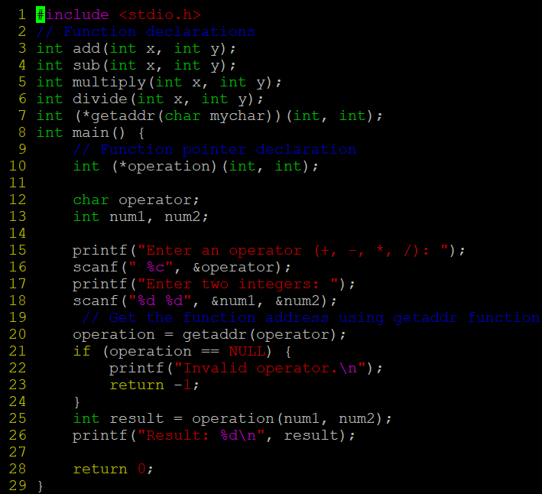

**OUTPUT:**

**3. Extend Q1 to include a function below which takes a function pointer to a calculator function and one integer (value = 10) as arguments and shall invoke the given function with required arguments. For the second argument read input from user. Return the result.**

**int invokefunc(<function pointer as argument1>, int val1);**

**OUTPUT:**

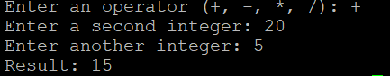

**4. Extend Q1 to define an array of function pointers and invoke them based user input character.**

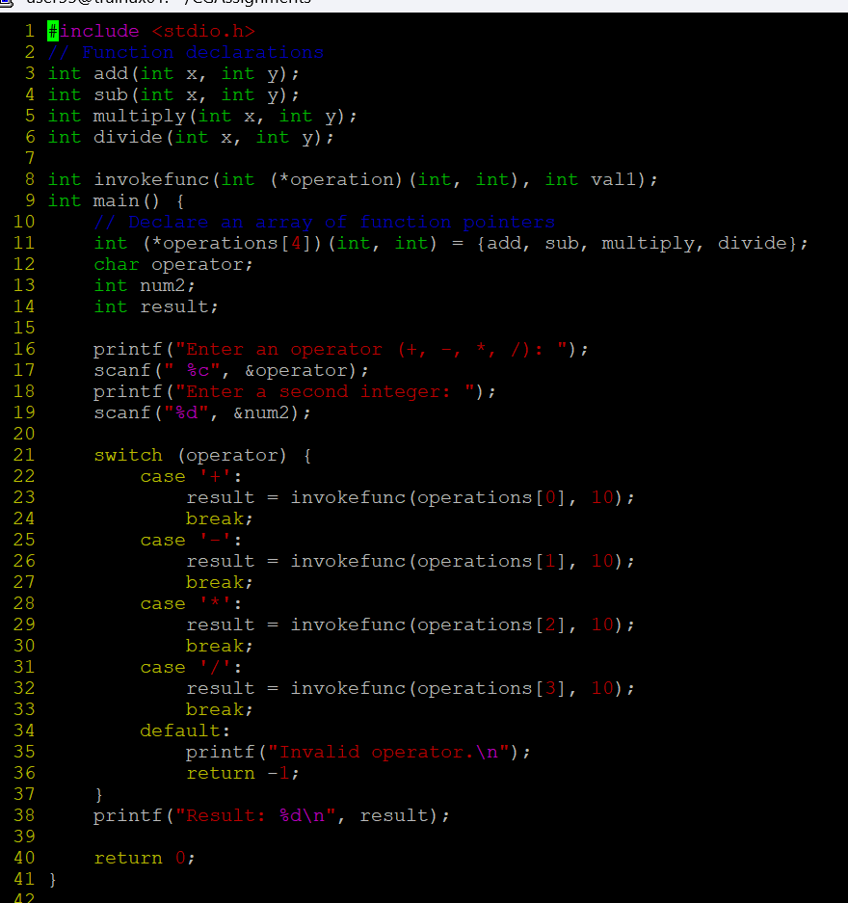

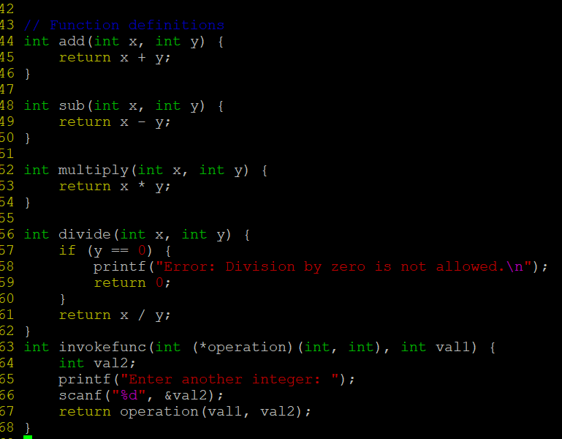

**OUTPUT:**

